Assignment B.2 - Milligan Chapter 4

Student Name: | < Replace this text with your name >

Week 3 - Milligan Chapter 4

Welcome to your hands-on activity! This assignment invites you to work with Tableau using a mix of generated and real-world data. You will:
- Download the attached spreadsheet and upload those data sets into Tableau. If you need help loading your data sources, refer to Assignment A.2 for help.
- Go through this document and use Tableau to answer all the questions listed below. Where applicable, paste screenshots into the template below.
- When you are ready, complete the online quiz which verifies your homework. You are welcome to refer to this document when you complete the quiz.
- You are welcome to use the quiz results to update your homework file.
- When you have completed the online quiz, submit the Word document.
- Remember, you can always reach out for help to your instructor if needed.
- If you need to adjust the size of your visualizations to match the options in the questions, use the “Format”->”Cell size” options. For example, “Ctrl+Shift+B” on a Windows computer will make the visualization bigger and “Ctrl+Up” will make it taller.

The spreadsheet attached to this assignment contains two datasets, each within its own sheet on the Excel doc:

- B.2 San Francisco Excel
- B.2 Student grades

Question 1: Calculated Field that Splits data

You work for the San Francisco energy audit and need to plan visits to the sites of the buildings that have upcoming energy audits. To plan your visits, you want to know how many are in each block of the city. Connect to the B.2 San Francisco Excel data and create a calculated field to create a new field from the parcel field so that you can get the block number which is the first set of digits in front of the slash.

Which of the following syntax would correctly create a field for just the block part of Parcel?

A: BREAK([Parcel(s)],"/")
B: SPLIT([Parcel(s)],"/",1)
C: DATEPARSE([Parcel(s)],1)
D: SPLIT([Parcel(s)],"-",1)

Question 1 Answer: | B : SPLIT([Parcelle(s)],"/",1)

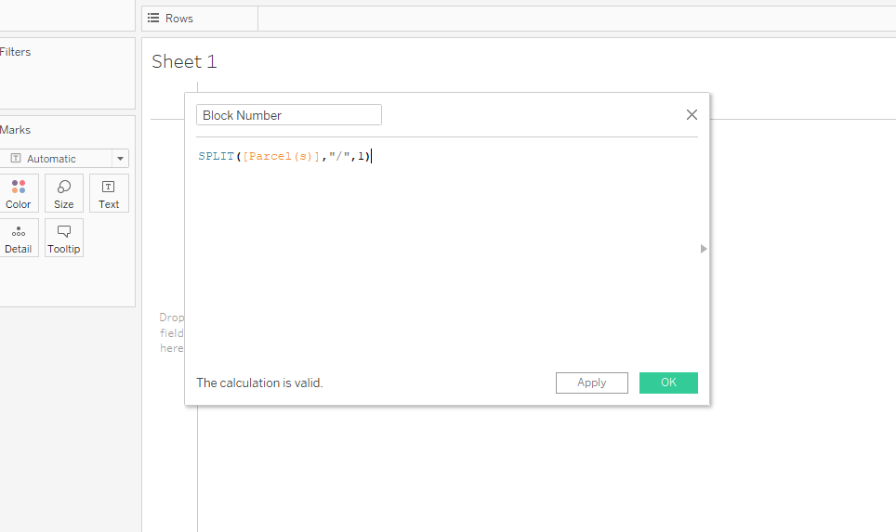

Question 2: Calculated Field using IF/THEN statements

The real estate agent who is trying to lease you one of the newest buildings claims that only 10% of the buildings in San Francisco have a floor area of 100,000 square feet or larger. We can use the IF/THEN functions to create a field displaying “Bigger than 100k SF” and “Smaller than 100k SF” as categories.
Using the B.2 San Francisco Excel data set, go to the Analysis menu at the top and select “Create Calculated Field".
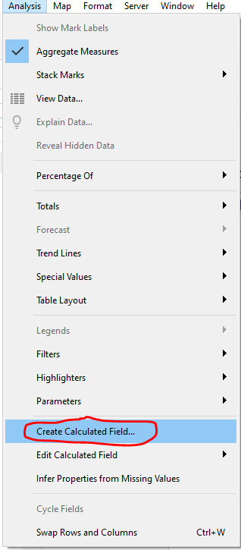

Change the name of the calculated field to 100K sqft

Enter the following Syntax:
IF [Floor Area]>= 100000
Then "Bigger than 100k SF"
ELSEIF [Floor Area]<100000
THEN "Smaller than 100k SF"
END
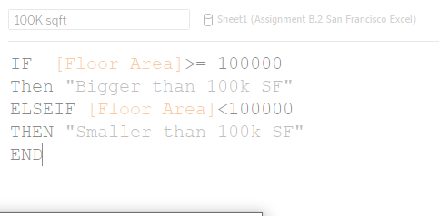

Now, you can make a bar chart to compare how many will fall into each category:
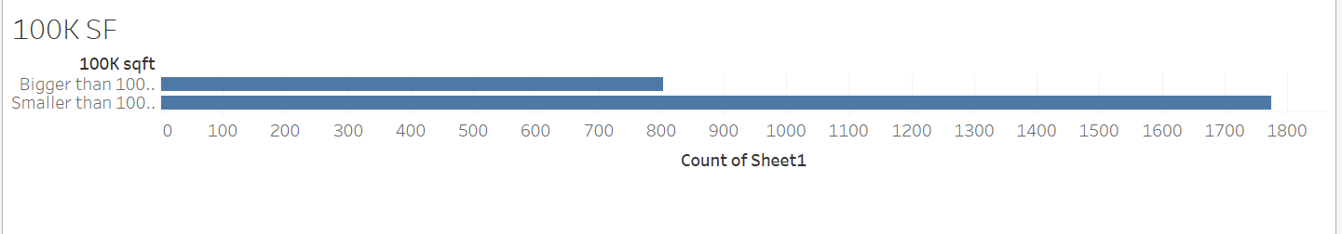

A local newspaper article claims that half of the buildings in San Francisco have been built since the last major earthquake in 1989. You decide to use your data to see if that is true. Using the IF/THEN for buildings built “Since last earthquake” and “Before 1989 earthquake”. Using this new field, make a bar chart showing the counts.

How many buildings have been built since the last earthquake?

- 129
- 389
- 2061
- 364

Question 2 Answer: | B) 389

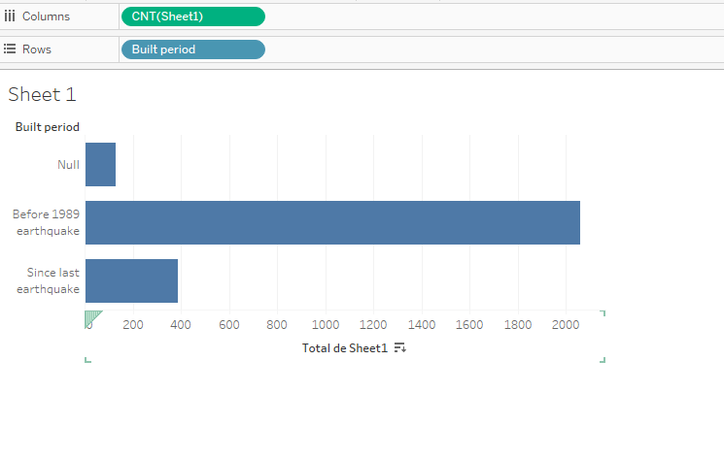

Question 3: Row-level calculation

You have been hired by an environmental consulting firm to help with heat calculations. We are still using the data set B.2 San Francisco Excel.

You have been asked to calculate the Source-Site Ratio, which measures the amount of heat (EUI) that is pulled from an external source (like a local power plant) compared to the amount of heat that is generated on-site at a building (geothermal or solar).

For example, if an individual building had a Source EUI of 100 kBtu/ft2, and a Site EUI of 25 kBtu/ft2, the building’s Source-Site ratio would be 100 / 25 = 4.

Create a calculated field that performs this Source-Site calculation for the year 2020. (Hint: you should have one calculation for each building with this data, and there should be approximately 845 of them in this data set.)

Suppose we want to know the distribution of the ratios across the locations. A histogram is a great way to see what the frequency is of the new Source-Site Ratio calculation. Drag the new measures from the data fields onto a blank worksheet. Click on “Show Me” in the top right corner and click on the image of the histogram.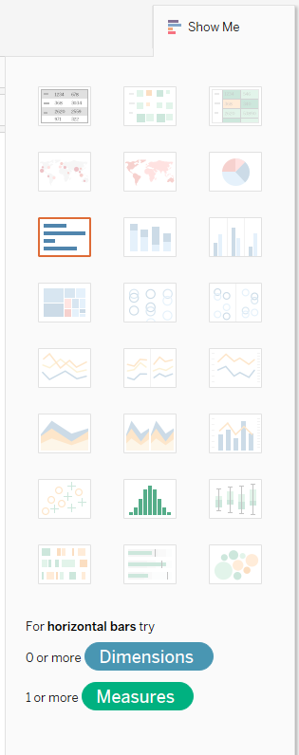

Which of the following histograms shows the distribution of the source-site ratio for 2020?

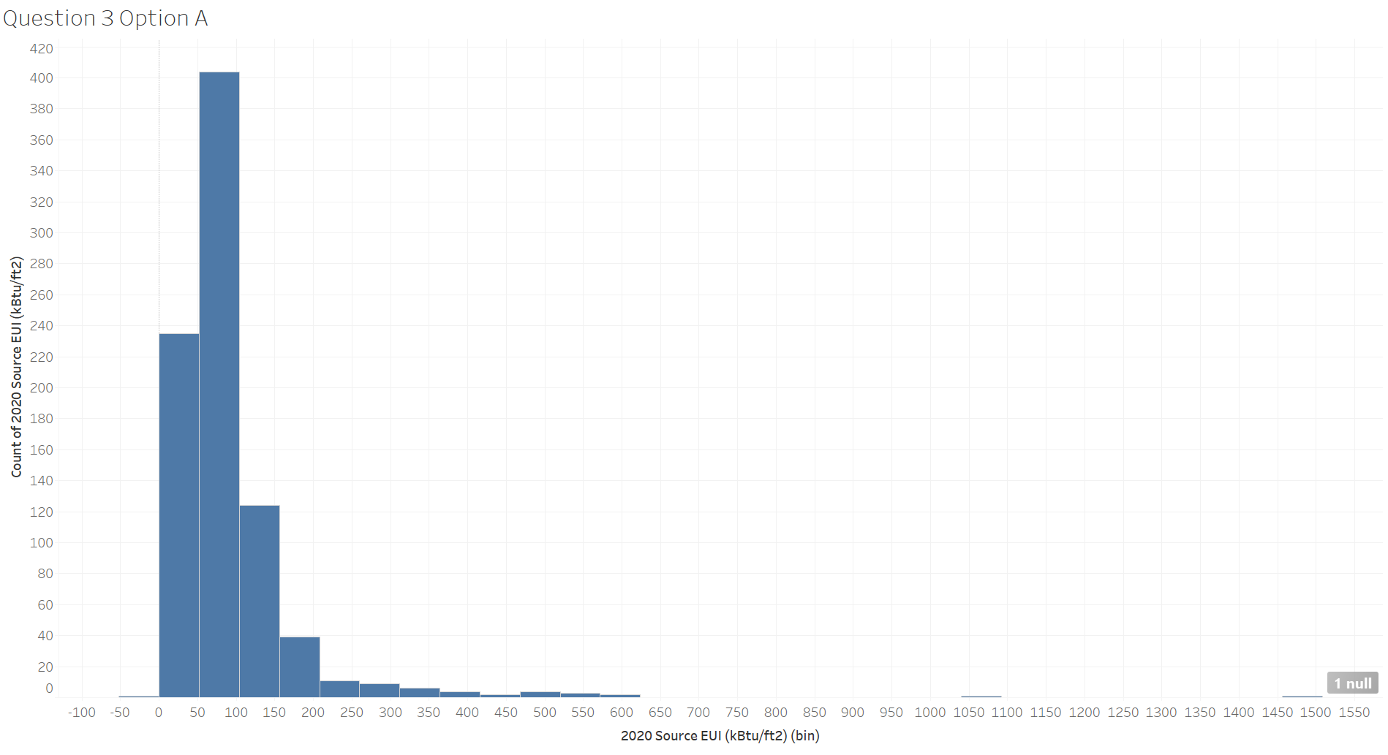 | 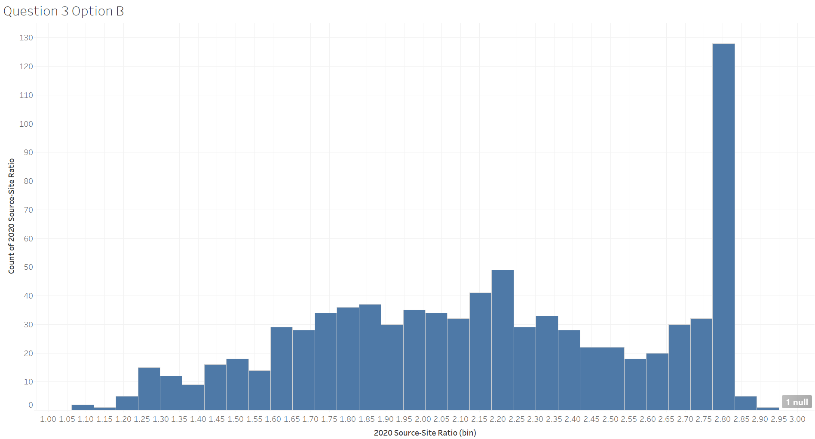
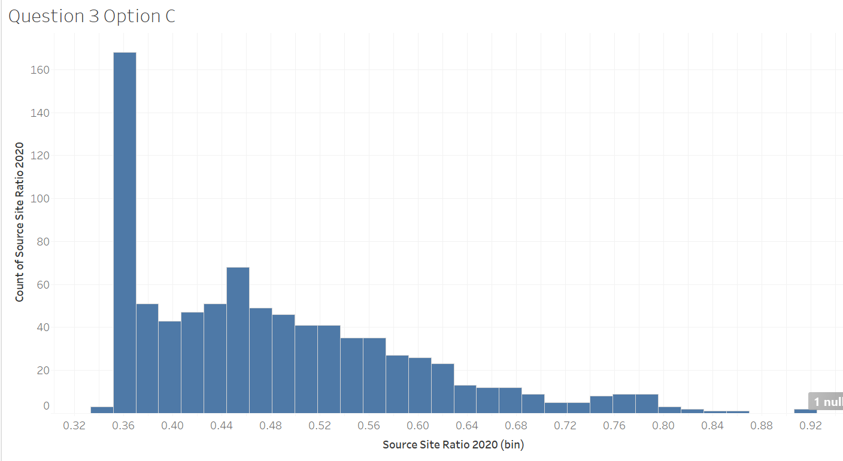 | 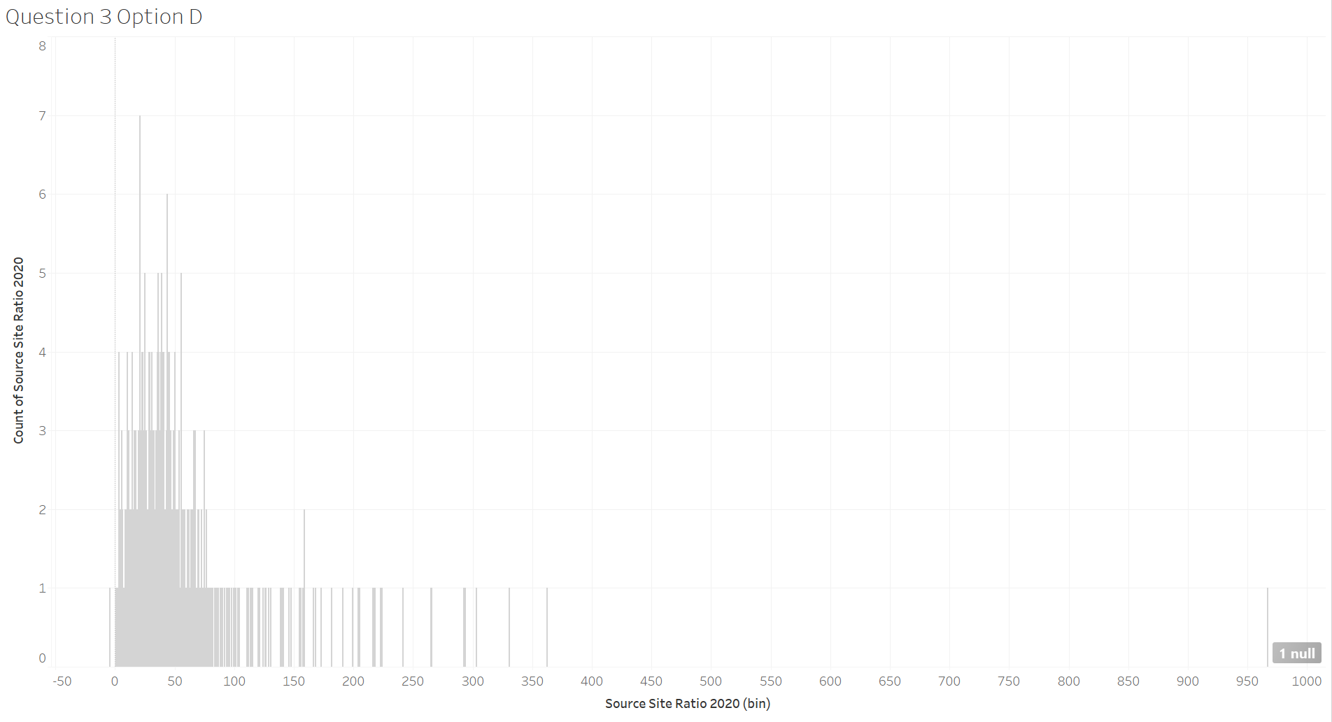

Question 3 Answer: | Option B

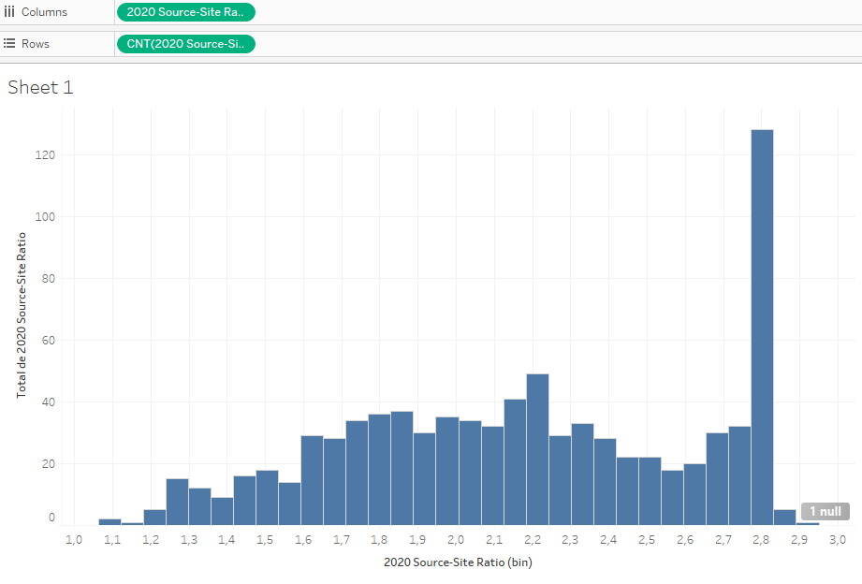

Question 4: Aggregate calculation

We need to know the average floor area for a series of visualizations that we will be doing. Create a new calculated field that calculates the average floor area. Now create a bar chart that breaks out the average floor area by property type and uses color to distinguish the “Earthquake status” (created in Question 2).

What is the average floor area of residential buildings built since the last earthquake?

- 484,500
- 81,867
- 218,779
- 178,852

Question 4 Answer: | - 484,500

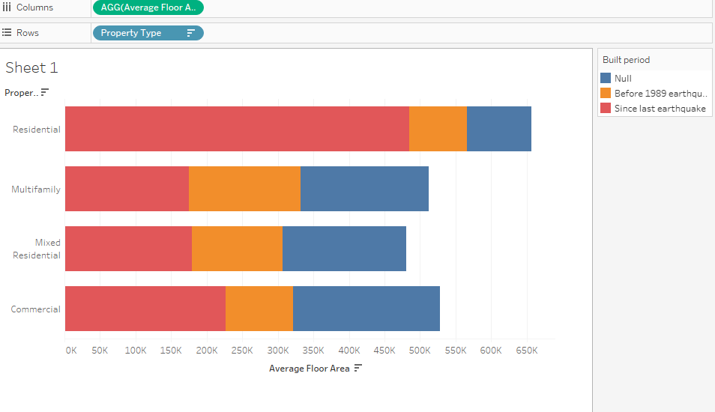

Question 5: Compare the totals for Row-level calculation and Aggregate calculation

For this question, load the B.2 Student grades workbook as a data source. Imagine that you are helping a teacher to perform calculations of their students’ grades. You create a calculated field called “Student Grade %” that takes the number of Points Correct divided by the Max Points. 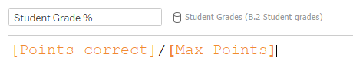
The teacher asks you to change the number format to percentage.

The teacher asks you for each student’s grade, and you provide this table:

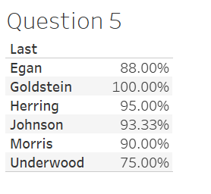
Then the teacher asks you what is the points correct, max points, and student grade overall in %. You provide this table below:
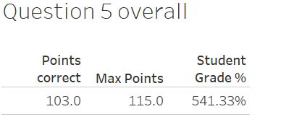

The teacher you are helping immediately notices that something is wrong! How can the students have an overall grade of 541.33% if they are only getting 103 points out of 115?

Go back to the drawing board and create an aggregated calculated field instead. Your new overall grade for students is:

Option A: 89.57%
Option B: 54.13%
Option C: 90.22%

Question 5 Answer: | Option C: 90.22%

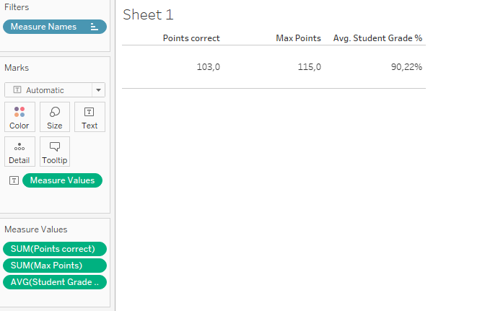

Question 6: Make a parameter

The teacher that you helped in Question 5 has asked for more help. The teacher wants to interact with the graph by entering a target final grade for their students. They want to know which students met the goal or not.

First, right-click on the Final Grade field in the data pane and select Create->Parameter.
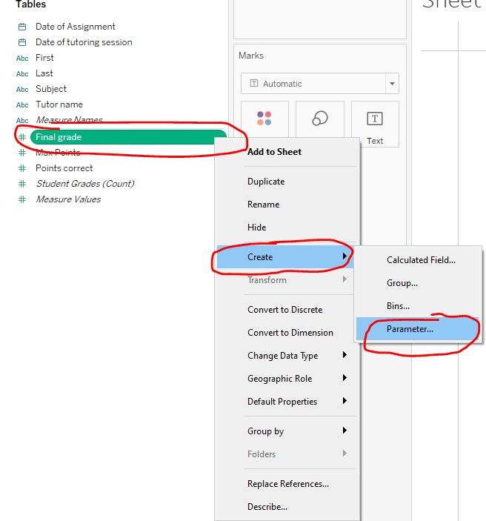

Next, change the name to “Final grade goal”. Set the current value to 70 and the minimum between 70 and 100.
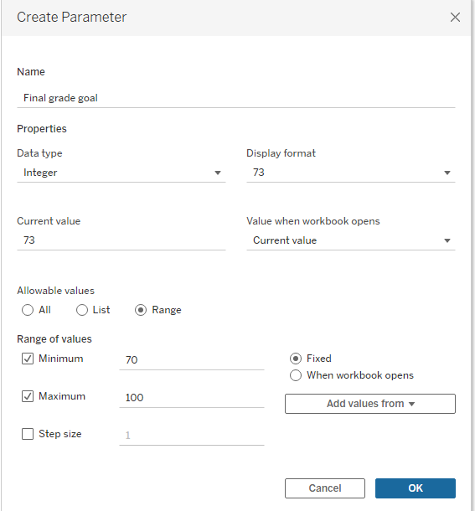

Now, create a calculated field called “Goal Met” and use the following Syntax to create an If/Then statement.

IF([Final grade] >= [Final grade goal])THEN 'Y' else 'N' END
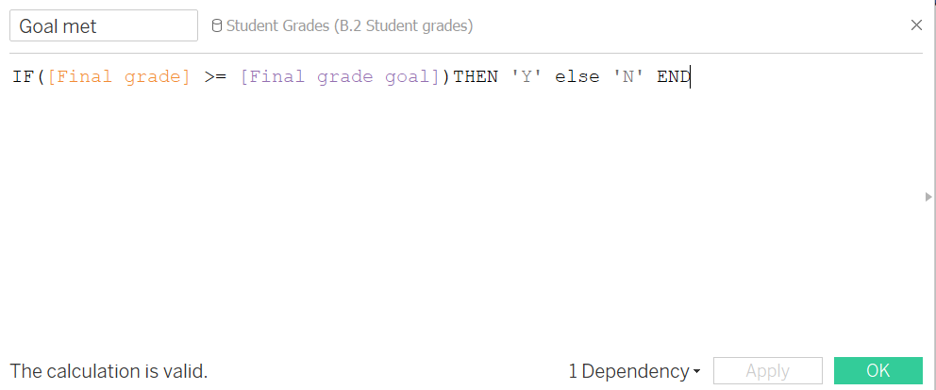

Now, create a bar chart with the Last name in the Rows and the Aggregate Calculated field “Overall Student Grade %” in the columns. 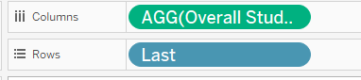Then drag the new calculated field, Goal Met, onto the Colors Mark.

Go back to the Parameter you made and right-click, make sure the “Show Parameter” has a checkmark. Now you should have a box in the upper right corner.
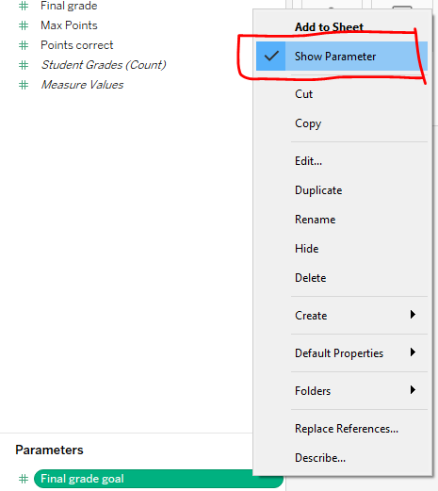
Your user should be able to change the amount in the parameter box. Change the amount to different values to test around. Which of the following graphs shows what happens when you change the goal to 90?

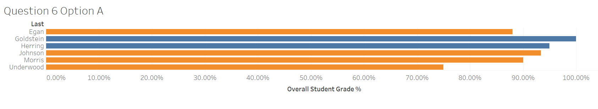 | 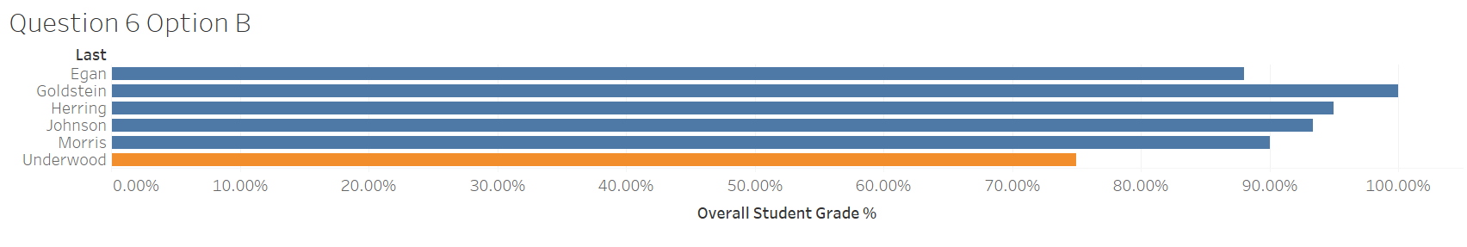
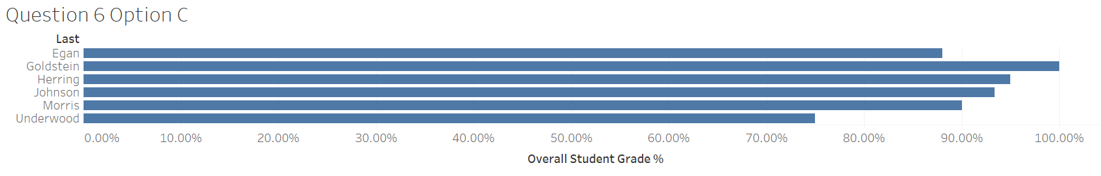 | 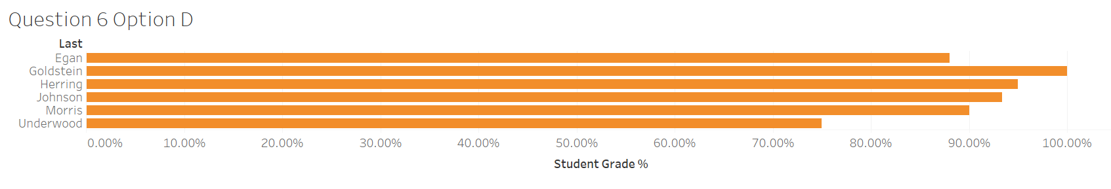

Question 6 Answer:

<<insert your screenshot>>

Question 7: Perform an ad hoc calculation

The teacher wants to see how the students performed in the various subjects. We will create a bar chart with the Subject dimension in the rows and the calculated field, Overall Student Grade % in the columns. Similar to the bar chart below.

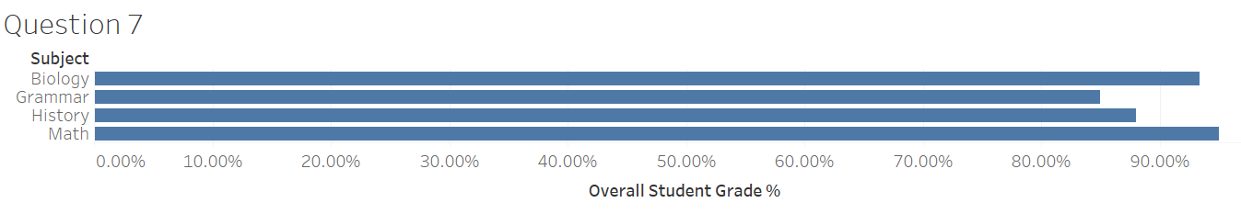Now, the teacher says that they want to know how many days between the date the student was tutored and the date of the assignment. We can do this using an Ad Hoc calculation - it will appear in the graph, but not become a new field.

Click in the blank area in Marks and enter the following syntax:
DATEDIFF('day', [Date of tutoring session],[Date of Assignment])

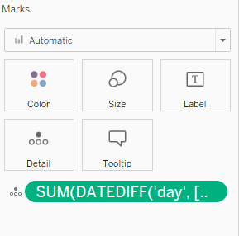
Drag that onto the color marks. Now, the color should have changed on your bar chart.
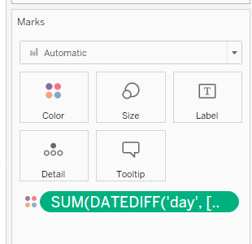
Which subject has the darkest color?

Option A: Math
Option B: Biology
Option C: Grammar
Option D: History

Question 7 Answer: | Option A: Math



